We are going to give many definitions

How can we define Political science?



“Politics is a complex social phenomenon that includes the activities of the governments, political parties and leading figures within them, lobbies and interest groups, and the general public, as well as political actors” w. Julian Korab and Karpowicz

“The term politics is derived from the Greek word polis which means the city state.” P.Kannan, K.Senthilvel



Political thought and political science, political sociology

**Lecture 03/ Part 01: Concepts of Political thought**

« Political science begins and ends with the State » J.W. Garner

Definition 01 :

« Politics means either the activities of political life or the study of these activities. And these activities are generally treated as the various activities of the various organs of government”

George Catlin

Definition 02:

Definition 05:

“Politics is the study of shaping and sharing political powers”

Who get, What, When, and How?

Harold Lasswell

Political science is, above all, descriptive study which brings together the description of national political institutions, their history, their ideological principles, their working, the forces that direct them, the influence they undergo, the results they obtain, and their effect on the life of the country and its relations with neighboring states.

Bridal

Definition 03:

Definition 04:

« Politics is the study of disagreements and reconciliations or resolution of them”

Peter B. Haris

“Political science revolves around the problem of the attainment, consolidations and distribution of political power whether in an actually existing state or a hypothetical state”

Definition 06:

We need also to define Political Sociology





Essential elements about political sociology :

* A sub-discipline of sociology and lies between it and political science.
* The relationship between the state and society.
* How can the political process be affected by major social trends.
* Politics varies according to society; politics is a dependent variable.
* Society comes before politics.
* Dealing with the social circumstances of politics; “how politics is shaped by and shapes other events in societies”

The main topics of the subject are:

* The historical context of political theories,
* The role of social groups,
* The formation of the state.

“Political sociology starts with society and examines how it affects the state”

R.Bendix / S.M.Lipset

Definition 01:

The main concept is **Power**:

* Who possess the power? i.e. The capacity to achieve his objectives and pursue their interests, even in case of a conflict between them and others ‘objectives.
* How this power is exercised and embodied in a form of institutions

Swaha Das and others, (2017, p-p: 3-5)

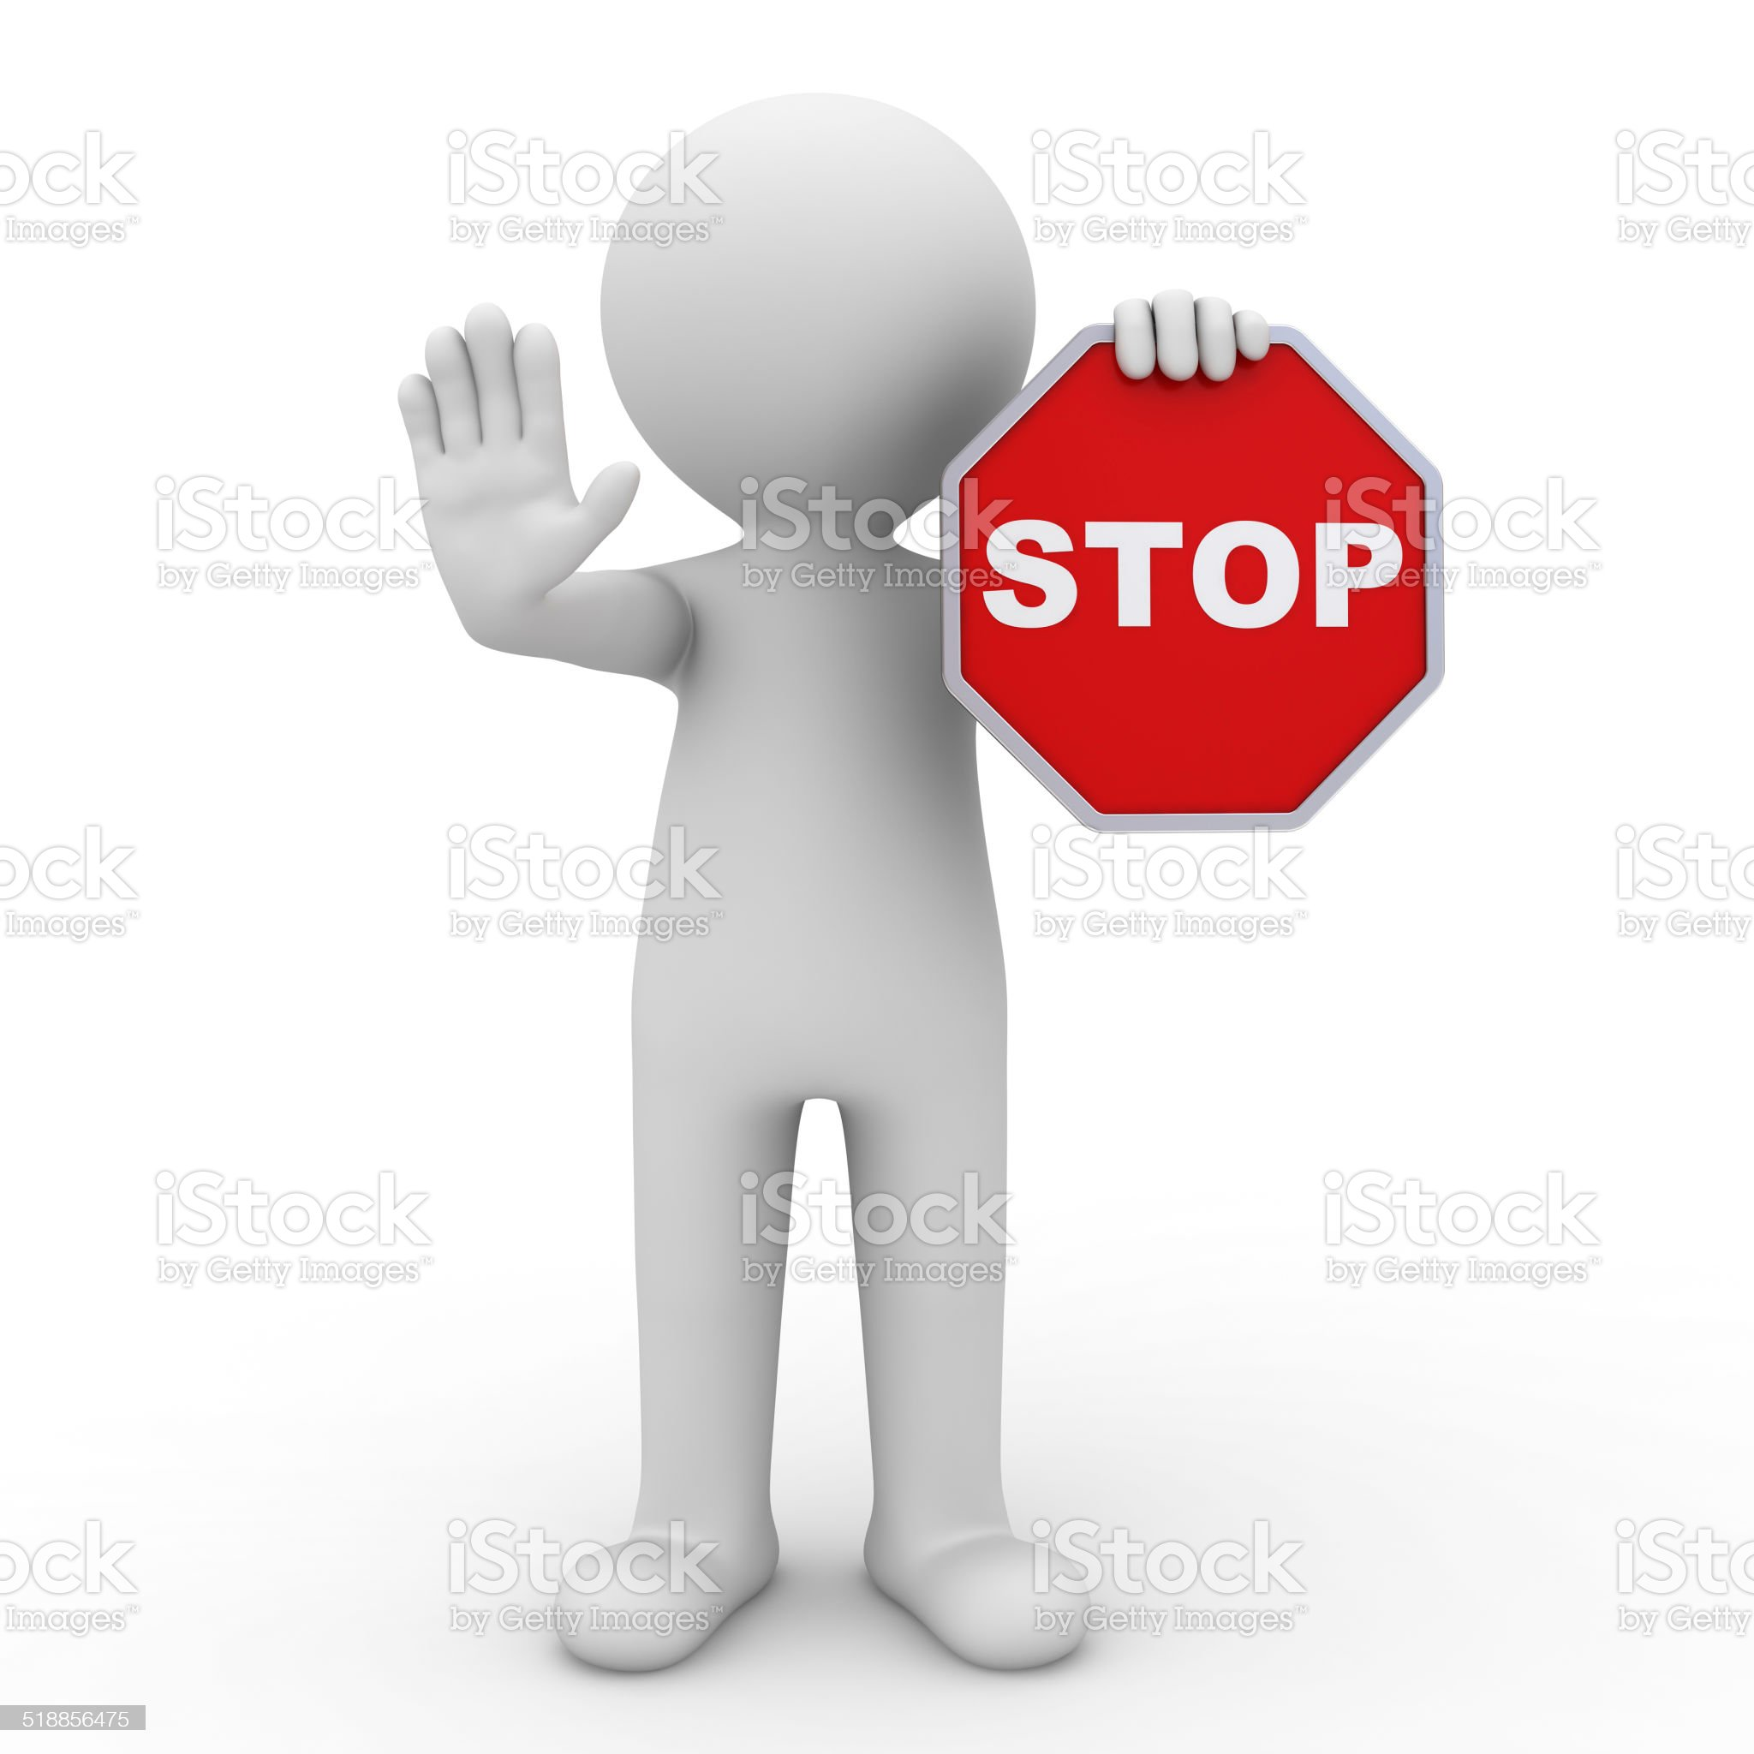

“The relationship between politics and society, it acknowledges that political actors (parties, pressure groups, social movements) operate within a wider social context. They, therefore, inevitably shape, and in turn, are shaped by, social structures (gender, class, nationality). Such social structures ensure that political influence within society is unequal.”

Keith Faulks

Definition 03:

“political sociology is that branch of sociology which is concerned with the social causes and consequences of given power distribution within or between societies, and with the social and political conflicts that lead to changes in the allocations of power. ”

Coser

Definition 02: