« We are all doing philosophy all the time. We can’t escape the question of what matters and why: the way we are living is itself our implicit answer to that question. A large part of a philosophical training is to make those implicit answers explicit, and then to examine them rigorously. Philosophical reflection, once you get started in it, can seem endlessly demanding. But if we can’t avoid living philosophically, it seems sensible to learn to do it well” David Egan (2019).

William J. Rapaport (2020,p39)



What is « Political philosophy » ?



Political thought and political philosophy

**Lecture 02/ Part 01: Concepts of Political thought**

What are the main subjects of philosophy ?

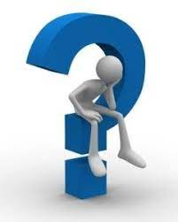



What about Politics and Political Philosophy ?

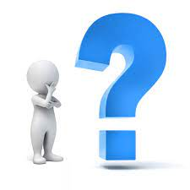



Adam Swift introduces his work “Political Philosophy” by an explanation of the way through which we can understand the relationship between politics and philosophy. He argues that, that can be through an examination of the disagreement between politicians about values, one of the main subjects of philosophy, and the difficulty to express those values, as he said:

“Politics is a confusing business. It’s hard to tell who believes in what. Sometimes it’s hard to tell whether anybody believes in anything. Politicians converge on the middle ground, worrying about focus groups, scared to say things that might be spun into ammunition by their opponents. There is so serious debate about policies but little about the values that underlie them. When it comes to principles, we have to make do with rhetoric, the fuzzy invocation of feel-good concepts. Who is against community, democracy, justice, or liberty? This makes it look as if values are uncontroversial. Politics comes to seem a merely technical matter: Politicians disagree about how best to achieve agreed goals and voters try to decide which of them has got it right”

Adam Swift, (2014, p13)

So, what do we mean by « Political Philosophy »?

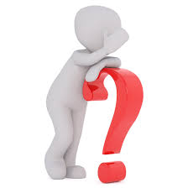

Craig: « Philosophical reflection on how best to arrange our collective lives, our political institutions and our social practices, such as our economic system and our pattern of family life”

Robert Paul Wolff: “Political Philosophy is the philosophical study of the state and the attitude of the citizens toward the state.

Alan Gewirth: The Central concern of political philosophy is the moral evaluation of political power”

Oyekunle O. Adegboyega, Emmanuel A. Akintona, ( 2020, p-p: 10-11 )



So, what does political thought tell us about « Political Philosophy »?



« From its beginning , Political philosophy has been essentially a normative theory that would identify sources of evil in a political community and prescribe a solution in the form of an ordering vision of what the community ought to become”

w. Julian Korab and Karpowicz

E. Barker argues that :

« Political Thought begins with the Greeks. Its origin is connected with what may be called the secularity of the Greek mind. Instead of projecting themselves into the sphere of the religion…, instead of taking this world on trust, and seeing it by faith, the Greeks took their stand in the realm of thought, and daring to wonder about things visible, they attempted to conceive of the world in the light of reason”

w. Julian Korab and Karpowicz explained that: Political philosophy was born when the Greek thinkers engaged with ethical and normative questions about politics, those questions took the form of distinguishing between the ways in which things were actually done and the way they should be done.

They added:

Political philosophers have never disregarded the knowledge of how things are, which can be regarded as the descriptive aspect of political philosophy. Their central concern, however, has been with “the ought”. They have been explicitly prescriptive or normative, asking:

“What most desirable for society and most just? What is the best social and political order?”

