* The pleasurable life.
* Pleasure generates the good and the blessed life.
* The removal of all kinds of pain.
* Ethical reasoning and Wisdom and

Prudence.

* Symbolon contract by all free and equal citizens for mutual peace
* How to live life?
* How to live it well?
* Virtue is always good
* Living according to nature
* Cosmopolitanianism

Zeno of Cyprus

Epicurus

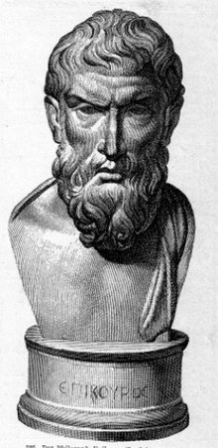

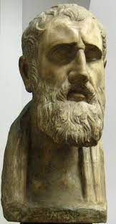

Philosophical Greek Schools