The philosophical foundations of political thought in the modern era

State of nature or (natural era - natural law) - reason - social contract

Definition of Natural Law

“In the human bosom there has always been a longing for a higher law than those made by the community itself. The divine theory of law, the theory of natural law and the principles of natural justice are some theories or notions found in fulfillment of this longing. Divine laws are those ascribed to God. Laws which are claimed to be God-made may not to be amendable by man; and their reasoning and provisions also not to be questioned by man”.

* « A body of immutable rules superior to positive law »
* “ The ideal law because it consists of the highest principles of morality towards which humanity is striving”
* An absolute law since it is not the result of any convention, but is discoverable by the exercise of reason.
* According to Grotius: the natural law is a dictate of right and reason, which points out that an act, according as it is or is not in conformity with rational nature, has in it a quality of moral baseness or moral necessity; and that in consequence such an act is either forbidden or enjoyed by the author of nature, God”.
* “Natural Law theory is based on human nature and experience that is both rational and creative. Principles and laws which promote and protect human rationality, creativity and dignity are then derived from philosophically articulated human structure”

***Natural Law***

Nature (physis) / positive Law (nomos)

“Natural law is morally prior to social convention and positive law”

“Natural justice exists in the properly ordered soul and city-state” (Plato)

“Natural Law provides universal moral principles obliging not only Roman citizens but all human beings” (Cicero)

“As ‘rational animals’, human beings must freely choose and intelligently pursue their end. Morality provides a path to true and perfect happiness, experienced partially in this life and completely in the next. ‘flourishing’ functions as the justification for virtues and moral standards rather than as the intentional and direct goal of every act. The agent ask herself, “What is the right thing to do? Or “What would a good person do in this situation?. Rather than “Which of these actions will most contribute to my flourishing? (Let alone, which of these options will make me happier?” (Thomas Aquinas).

***Reason***

According to Aristotle:

* There is a reason for everything.
* These reasons are contained within the rational forms.
* The reasons do not exist physically but conceptually.
* Material things are then mixed with the rational forms.
* The material substance and the rational form exist in tandem.
* Material substance and rational form are of equal worth.
* They exist to complement each other.
* They have different functions.
* Human beings have body (soma) and soul (psyche).
* Other things have material substance and rational form.

According to Thomas Aquinas:

“Law is the ordinance of reason, ordered to the common good, made by one who care for a community, and communicated publicly. ‘Law’ governs in analogous ways the created world (eternal law), human behavior (natural law), particular human political communities (temporal law or positive law), and the Christian life (divine law).

The natural law is the rational creature’s participation in the eternal law. This participation is both reasonable and natural: each person must use his or her reason to discover what accords with ‘right reason’ in any particular situation, the ‘right reason’ always conforms to the order inscribed by the creator in nature”.

***State of Nature***

“It is a situation without government”

“It is the conditions under which men lived prior to the formation of societies”

“Assuming that a State of Nature existed allows one to analyze society in such a way as to provide a direction for suggesting what are the ends of the state which will remedy the problems illustrated in the State of Nature”.

***Social Contract***

“In political philosophy, a social contract is an actual or [hypothetical](https://www.merriam-webster.com/dictionary/hypothetical) compact, or agreement, between the ruled or between the ruled and their rulers, defining the rights and duties of each”

Political philosophy among the pioneers of the social contract.

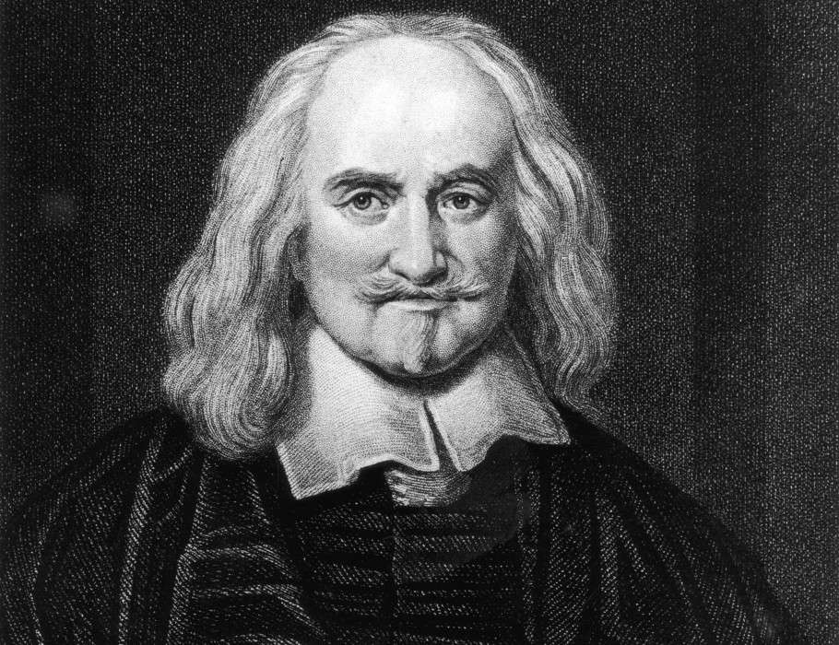

Thomas Hobbes (1588-1679)

* Leviathan (1651).
* State of nature where no law exist, life in it is solitary, poor, nasty and short and also than man is in continual fear, and in danger of a violent death. People were naturally aggressive and that conflict was a normal part of human nature.
* Once we begin to examine life without rules and regulations we can really begin to question and reflect on our morality.
* People are anti-social, competitive, fearful and selfish.
* Our actions are governed by the law not our conscience.
* People are self-motivated and only act for their own self-interest in addition to fear of others.
* In this situation, an all-powerful sovereign is needed to rule over them.
* The best solution for people to escape war and violence is by giving up their natural rights and submitting to the rule of a strong ruler.
* Social contract is an agreement in which people gave up rights in exchange for law and order. It is an agreement between society and its state. In order to have a more secure and comfortable life.
* The support for powerful rulers more than the rights of the individuals.
* The absolute power to a sovereign ruler.
* The best government is monarchy, where an individual protects his subjects from chaos, civil war, and violence through fear and punishment for acts of disobedience.

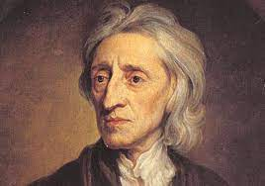

John Locke (1632-1704)

* Two Treatises of Government (1689).
* “Men being, as has been said, by nature, all free, equal and independent, no one can be put out of this estate, and subjected to the political power of another, without his own consent.” John Locke
* “The state of nature is only a pre-political state: an organized society without established government.
* The government should exist for the people to protect their liberty, property and life.
* If the government fails to work for the welfare of the society, people have every right to rebel against the government and they can change it.
* Man gives up his freedom and power, because the enjoyment of it is very uncertain and constantly exposed to the invasion of others.
* The most important end of men’s uniting into a commonwealth is for the mutual preservation of their lives, liberties, and estates.
* By means of contract the individuals agree to submit their powers (natural rights) to a majority rule in order to organize themselves
* A partial surrender of natural rights.
* Separation between legislative and executive power”.

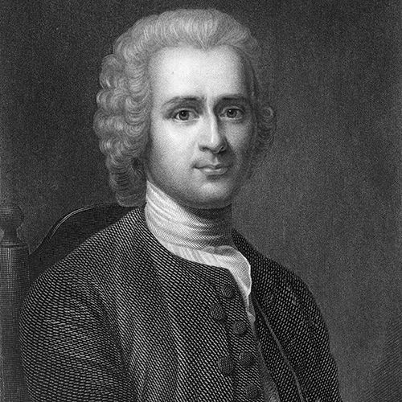

John Jacques Roussou (1712-1778)

* Discourse on the Origin and Basis of Inequality among Men (1755).
* “The state of nature is a state of happiness and enjoyment, peace and tranquility, independence, equality, and freedom.
* All individual rights (property rights also), are subordinate to the general will.
* The state is a moral person whose life is the union of its members, whose laws are acts of the general will.
* The end of the state is the liberty and equality of its citizens.
* The social contract is broken when the government usurps the power of the people.
* When the social contract is broken, the citizens are no longer to obey, they have an obligation to rebel”.

Political philosophy of the European Enlightenment

***( The age of Reason)***

An intellectual movement 18th century

* “The emphasis on the individual;
* Critical thinking;
* Rejection of the traditionally imposed way of thinking whether by religion or any other overarching authority
* The intellectual freedom;
* The use of reason for seeking knowledge and progress;
* The importance of secular education; beyond the formal schooling by the religious institutions;
* Rejection of traditional and religious dogma with an appeal to reason + emphasis on the individual = rationalism and individualism
* All human beings were innately good and reasonable
* An emphasis on the popular sovereignty and the rule of law.
* Rejection of unbridled powers in the hands of the rulers, whether monarchs or otherwise.
* the existence of God. However, he was reasonable and non-interfering. Many of the Enlightenment thinkers believed in deism which meant that the creator of the universe was God but who did not interfere in the working of universe or human society”.

Nationalist and liberal political philosophy

- Frederick Hegel

- John Stuart Mill

«  The combination between :

* Rational freedom of the sort realized through a general will.
* The historical development in which conflicting particular interests lead to a moral society.
* Custom, tradition”.

The defense of individual liberty (Mill’s Liberty Principle):

“The sole end for which mankind are warranted, individually or collectively, in interfering with the liberty of action of any of number is self-protection. That the only purpose for which power can be rightfully exercised over any member of a civilized community, against his will, is to prevent harm to others”

**References:**

* <https://onlinelibrary.wiley.com/doi/pdf/10.1111/j.1468-2230.1958.tb00498.x>
* <https://scielo.conicyt.cl/pdf/abioeth/v8n1/art09.pdf>
* <https://ijtr.nic.in/articles/art62.pdf>
* <https://www.bc.edu/content/dam/files/centers/boisi/pdf/f09/Pope_Reason_and_Natural_Law.pdf>
* <https://www.abdabrs.com/uploads/5/1/0/4/51042467/natural_law_-_richard_wright__ure__old_spec.pdf>
* <https://www.academia.edu/38535213/State_of_nature>
* <https://www.encyclopedia.com/social-sciences-and-law/sociology-and-social-reform/sociology-general-terms-and-concepts/state-nature>
* <https://www.iilsindia.com/study-material/654357_1601747115.pdf>
* <https://webofproceedings.org/proceedings_series/ESSP/IEESASM%202020/WHYD047.pdf>
* <https://www.britannica.com/topic/social-contract/The-social-contract-in-Rousseau>
* <https://www2.econ.iastate.edu/classes/econ362/hallam/Readings/SocialContractHelium.pdf>
* <https://www.nypl.org/sites/default/files/hobbes.pdf>
* <https://k12database.unc.edu/wp-content/uploads/sites/31/2014/03/EnlightenmentPPT.pdf>
* <https://mrsmercerdms.weebly.com/uploads/8/7/1/1/87112442/the_enlightenment__age_of_reason__student_copy__3_.pdf>
* <https://scholarcommons.scu.edu/cgi/viewcontent.cgi?article=1035&context=phi>
* <https://tfreeman.net/resources/Phil-320/15.-Mill.pdf>