Islamic political thought in the modern era

Liberal Trend: Rifaa Al-Tahtawi

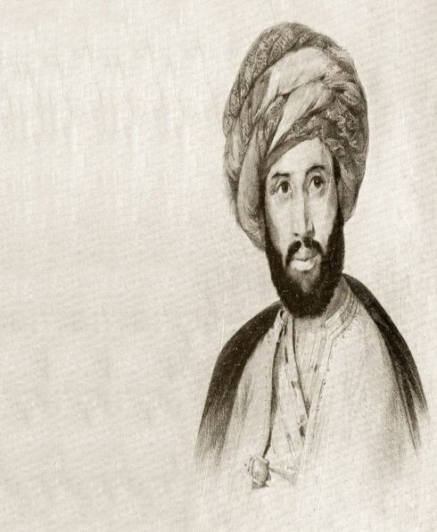

“Justice is the basis of prosperity. . . . That which [the French] call freedom and which they crave is what we call 'justice' and 'equity', inasmuch as 'rule by freedom' means establishing equality in judgments and laws so that the ruler cannot oppress any human being.”

Revolutionary Trend: Jamal al-Din al-Afghani

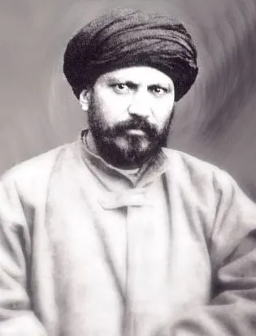

It is not the religious beliefs, whether right or wrong, which are opposed to culture and material progress, but that belief which prohibits learning of sciences, earning one's livelihood and the ways of culture. I do not believe that there is any religion in the world which opposes these things. I would rather say that it is non-believing which inevitably leads to disorder and distortion of culture as in the case of the Nihilists.

The Reformist Trend: Muhammad Abdo, Muhammad Rashid Reda, according to Abdul Rahman Al-Kawakibi

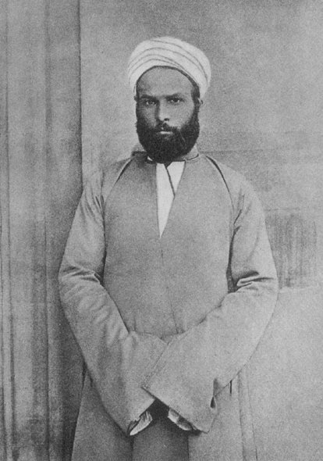

“I went to the West and saw Islam, but no Muslims; I got back to the East and saw Muslims, but not Islam.”

Muhammad Abdo

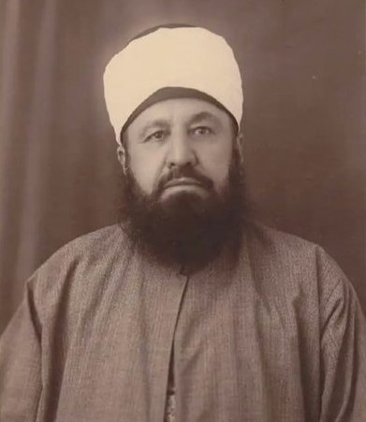

“Oppression manipulates facts in people’s minds, leading people to believe that whoever seeks truth is sinful, that whoever abandons his rights is obedient, that the one who cries out [against oppression] is mischievous, that the perceptive and intelligent are godless, and that the useless one is upright. It transforms genuine advice into intrusiveness, caring for others into enmity, magnanimity into transgression, enthusiasm/zeal into foolishness, mercy into illness, just as it considers hypocrisy to be a policy, manipulation to be civility, and pettiness/villainy to be kindness.”

Abdul Rahman Al-Kawakibi

"To revolt on behalf of an ignorant people, is like to set yourself on fire in order to light the way for a blind man!"

Muhammad Rashid Reda



Nationalist political thought according to Sati’ al-Husri



« The foundations for formulating nation and nationalism are unity of language and history this is because unity in these two factors paves the way for unity of feeling and inclinations, unity of sufferings and hopes, unity of culture and traditions, thus making the people feel that they are the sons of one nation, distinguished from other nations”

(Rahaf Aldoughli,p14)

<https://www.goodreads.com/author/quotes/12474965.Rifa_a_Rafi_al_Tahtawi>

<https://libquotes.com/jamal-al-din-afghani>

<https://ballandalus.wordpress.com/2013/08/07/abd-al-rahman-al-kawakibi-d-1902-on-the-nature-of-oppression/>

<https://twitter.com/OlufemiAwoyemi/status/1145224287730700288>

<https://www.azquotes.com/author/41763-Muhammad_Abduh>

<https://core.ac.uk/download/pdf/77612622.pdf>