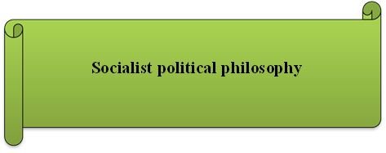

“An economic theory based on the premise that voluntary surrender by capital of the means of production would bring about the end of poverty and unemployment”

“Socialism achieved by voluntary sacrifice”

“A branch of socialism that was developed by Karl Marx and Friedrich Engels in the mid-1800s as a means to analyze the system of capitalism and encourage revolutionary change in society”

“A democratic welfare state that incorporates both capitalist and socialist practices”

“A socialist system of government achieved by democratic means”

<https://www.thefreedictionary.com/utopian+socialism>

<https://study.com/academy/lesson/scientific-socialism-history-divisions-applications.html>

<https://www.merriam-webster.com/dictionary/social%20democracy>