“True wisdom consists in two things: Knowledge of God and Knowledge of Self.

No man is excluded from calling upon God, the gate of salvation is set open unto all men: neither is there any other thing which keeps us back from entering in, save only our own unbelief”

“From the beginning of my Reformation I have asked God to send me neither dreams, nor visions, nor angels, but to give me the right understanding of His Word, the Holy Scriptures; for as long as I have God's Word, I know that I am walking in His way and that I shall not fall into any error or delusion”

John Calvin

Martin Luther

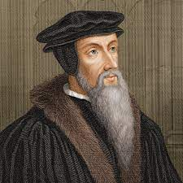

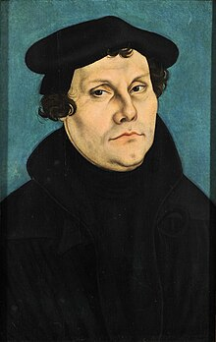

The Reformation movement of Martin Luther and John Calvin