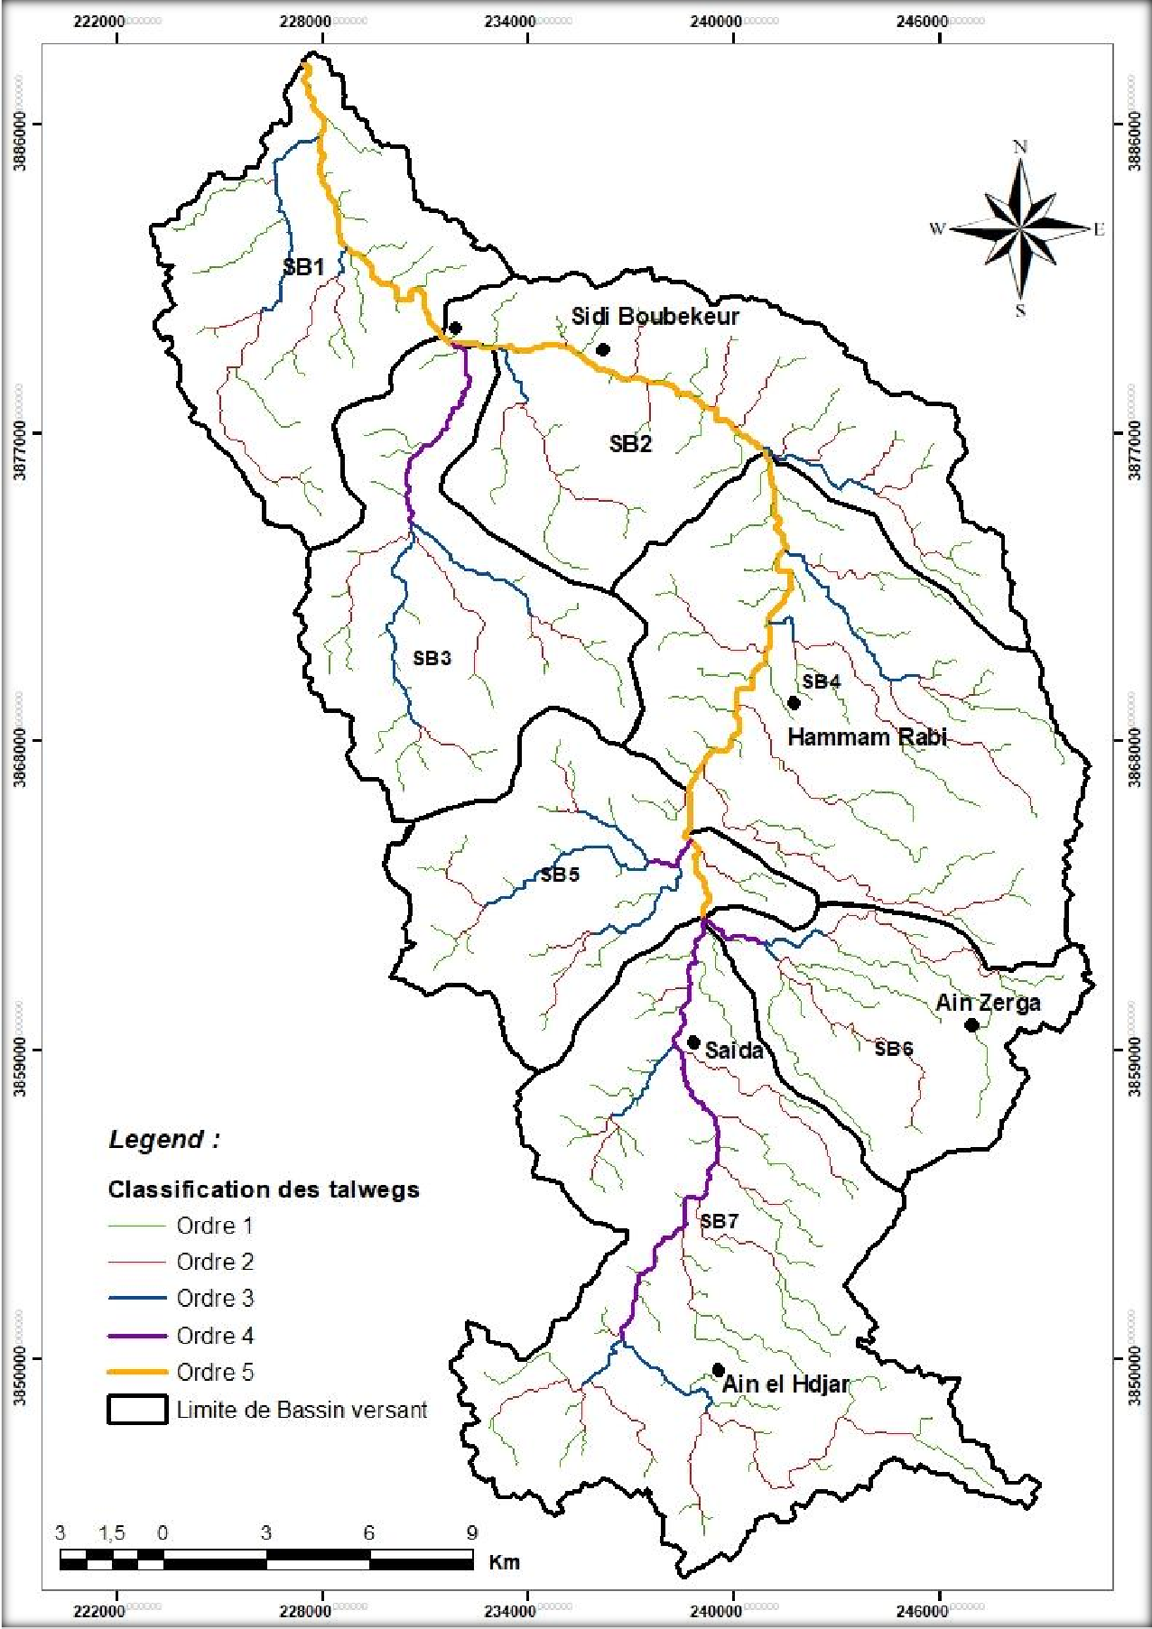

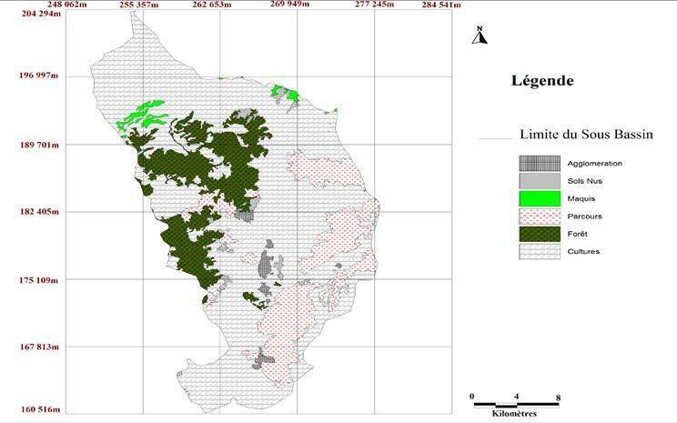

Figure II. 11 Carte d’occupation du Sol (bassin Versant de Saida)

*Les principales caractéristiques physiographiques du bassin versant

Sous bassin | Surface km² | CN | Lag_time( min)= tc/6 | Temps de  concentration heurs tc
Sb1 | 74.8 | 65 | 109.99 | 3.05
Sb2 | 94 | 67 | 198.85 | 5.52
Sb3 | 77 | 60 | 202.68 | 5.63
Sb4 | 113 | 65 | 232 | 6.45
Sb5 | 64 | 70 | 203 | 5.65
Sb6 | 140 | 69 | 235.2 | 6.54
Sb7 | 140,7 | 80 | 344,16 | 9.55

N BV | P (km) | S (km2) | L | l | KG | Hmax | Hmin | H moyen | Pente moyen  % | Pente moyen deg | Tc (Giandotti)
SB1 | 57,75 | 74,80 | 25,77 | 3,11 | 1,87 | 939,00 | 439,00 | 689,00 | 1,94 | 5,15 | 3.05
SB2 | 54,94 | 94,50 | 23,20 | 4,27 | 1,58 | 1075,00 | 519,00 | 797,00 | 2,40 | 8,25 | 5.52
SB3 | 65,70 | 77,60 | 30,03 | 2,82 | 2,09 | 1156,00 | 522,00 | 839,00 | 2,11 | 7,79 | 5.63
SB4 | 63,23 | 113,00 | 27,24 | 4,37 | 1,67 | 1116,00 | 594,00 | 855,00 | 1,92 | 4,67 | 6.45
SB5 | 58,77 | 64,80 | 26,75 | 2,63 | 2,04 | 1187,00 | 676,00 | 931,50 | 1,91 | 6,11 | 5.65
SB6 | 65,55 | 74,60 | 30,06 | 2,71 | 2,13 | 1160,00 | 698,00 | 929,00 | 1,54 | 6,26 | 6.54
SB7 | 99,85 | 140,70 | 46,55 | 3,38 | 2,36 | 1225,00 | 754,00 | 989,50 | 1,01 | 4,82 | 9.55

Données climatologiques :
* Pluies de courte durée
Temps (heurs) | Les pluies de courte durée (PTC calculée par courbe IDF /période de retour =100 ans fréquence 1%)
1 | 20.7523314
2 | 27.0058774
3 | 31.5045275
4 | 35.1438786
5 | 38.2538803
6 | 40.9981602
7 | 43.4714522
8 | 45.7342002
9 | 47.8276505
10 | 49.7813756
11 | 51.6173987
12 | 53.3526219
13 | 55.0003391
14 | 56.5712203
15 | 58.0739775
16 | 59.5158289
17 | 60.9028314
18 | 62.2401234
19 | 63.5321075
20 | 64.7825877
21 | 65.9948772
22 | 67.1718813
23 | 68.3161638
24 | 69.43

