Pumping test
A pumping test is a field experiment in which a well is pumped at a controlled rate and water-level response (drawdown) is measured in one or more surrounding observation wells and optionally in the pumped well (control well) itself; response data from pumping tests are used to estimate the hydraulic properties of aquifers, evaluate well performance and identify aquifer boundaries. Aquifer test and aquifer performance test (APT) are alternate designations for a pumping test. In petroleum engineering, a pumping test is referred to as a drawdown test.

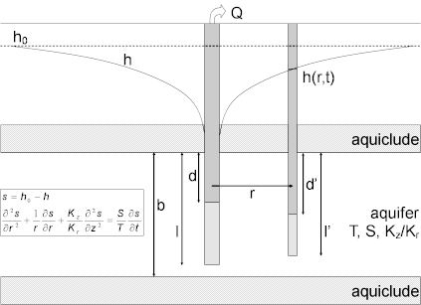

The goal of a pumping test, as in any aquifer test, is to estimate hydraulic properties of an aquifer system. For the pumped aquifer, one seeks to determine transmissivity, hydraulic conductivity (horizontal and vertical) and storativity (storage coefficient). In layered systems, one also uses pumping tests to estimate the properties of aquitards (vertical hydraulic conductivityand specific storage). Pumping tests can identify and locate recharge and no-flow boundaries that may limit the lateral extent of aquifers as well.
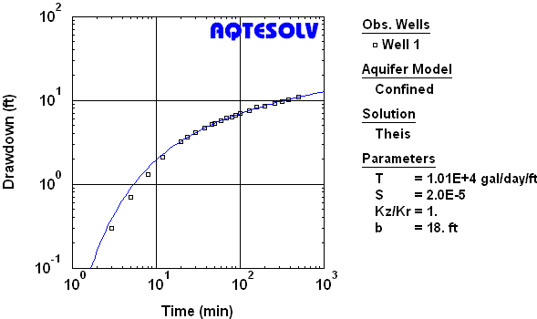
Fig Estimation of aquifer properties by matching Theis (1935) type-curve solution to time-drawdown data collected in an observation well during a constant-rate pumping test in a nonleaky confined aquifer

Typically, aquifer properties are estimated from a constant-rate pumping test by fitting mathematical models (type curves) to drawdown data through a procedure known as curve matching (Figure 2). Diagnostic tools such as derivative analysis are useful for identifying flow regimes and aquifer boundaries from a pumping test prior to performing curve matching.
Prior to performing a pumping test in the field, one should spend time in the office developing a thorough plan for the test. Proper planning includes the design of the test, acquisition and preparation of field equipment, measurement and control of flow rates, measurement locations and schedules (with pre- and post-test collection periods) for water levels, disposal of pumped water and test duration.

Types Of Pumping Tests
Common types of pumping tests that you may perform include the following:
- Constant-rate tests maintain pumping at the control well at a constant rate. This is the most commonly used pumping test method for obtaining estimates of aquifer properties.
- Step-drawdown tests proceed through a sequence of constant-rate steps at the control well to determine well performance characteristics such as well loss and well efficiency.
- Recovery tests use water-level (residual drawdown) measurements after the termination of pumping. Although often interpreted separately, a recovery test is an integral part of any pumping test.

