Lecture 01: Introduction to History of Political Thought
According to Cambridge dictionary: Thought is a noun that is derived from the verb to think, it means:
- to believe that something is true, or to expect that something will happen, although you are not sure.
- to use the brain to plan something, solve a problem, understand a situation, etc.

A thought is an idea or opinion

Political is an adjective, it is derived from the word Poltics, it means :
- relating to or involved in politics
According to Oxford dictionary, political means:
- Of, belonging to, or concerned with the form, organization, and administration of a state, and with the regulation of its relations with other states.

Political Thought is about the ideas and opinions that are related to political life.
In the academic realm, it is the study of the different ideas expressed by famous thinkers and philosophers whose works shaped the foundation of political science, each of them has described the political life in a certain way either to say what is politics or how it ought to be.

“I am not Athenian, or a Greek. I am a citizen of the world.”

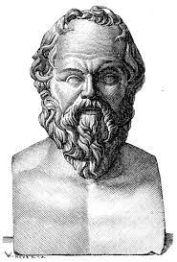

- Socrates

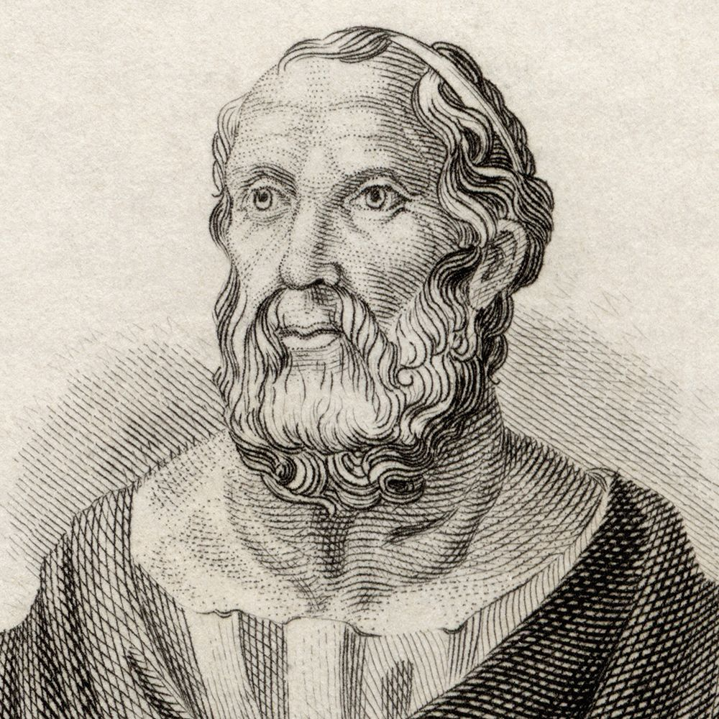

He who does not desire power is fit to hold it.

2. Plato

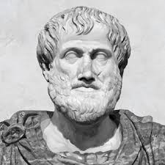

He who is to be a good ruler must have first been ruled.

3. Aristotle

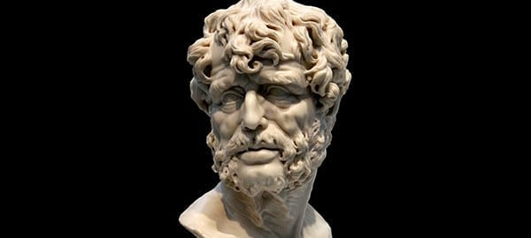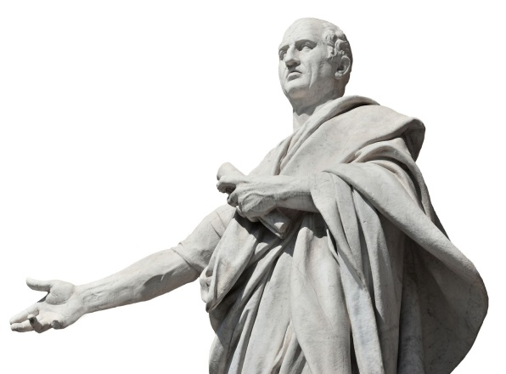
- Cicero

- Seneca

To govern was to serve not to rule.
A hated government does not long survive
Politicians are not born; they are excreted.
A nation can survive its fools, even the ambitious. But it cannot survive treason from within….for the traitor appears not to be a traitor…he rots the soul of a nation…he infects the body politic so that it can no longer resist

Allah guards the justice loving government, even if it is the government of non-Muslims, and destroys the tyrant government, even if it is the government of Muslims
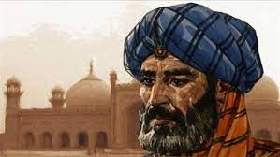

6. Ibn-taymiyyah

There is nothing that leads faster decay of the world and degeneration of people's conscience than injustice
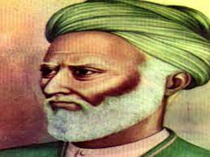

7. Al-mawardi

A just city should favor justice and the just, hate tyranny and injustice, and give them both their just deserts
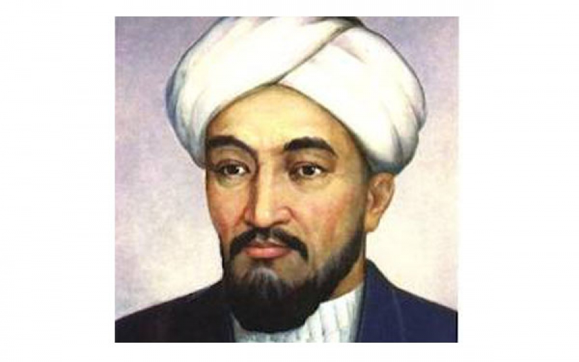

8. AL-farabi

People say that wisdom is precious but the world pays no penny for it
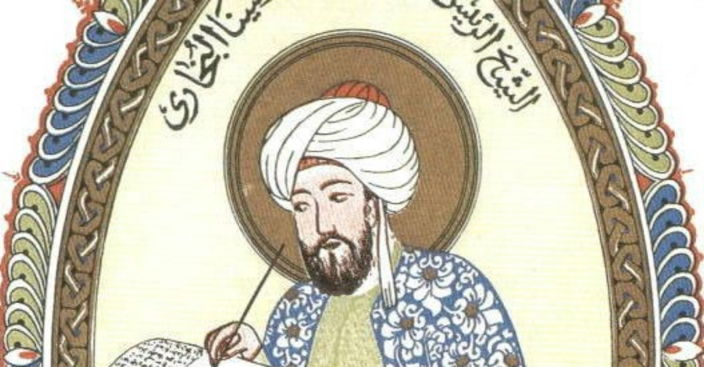

9. Avicenna

Throughout history many nations have suffered a physical defeat, but that has never marked the end of a nation. But when a nation has become the victim of a psychological defeat, then that marks the end of a nation
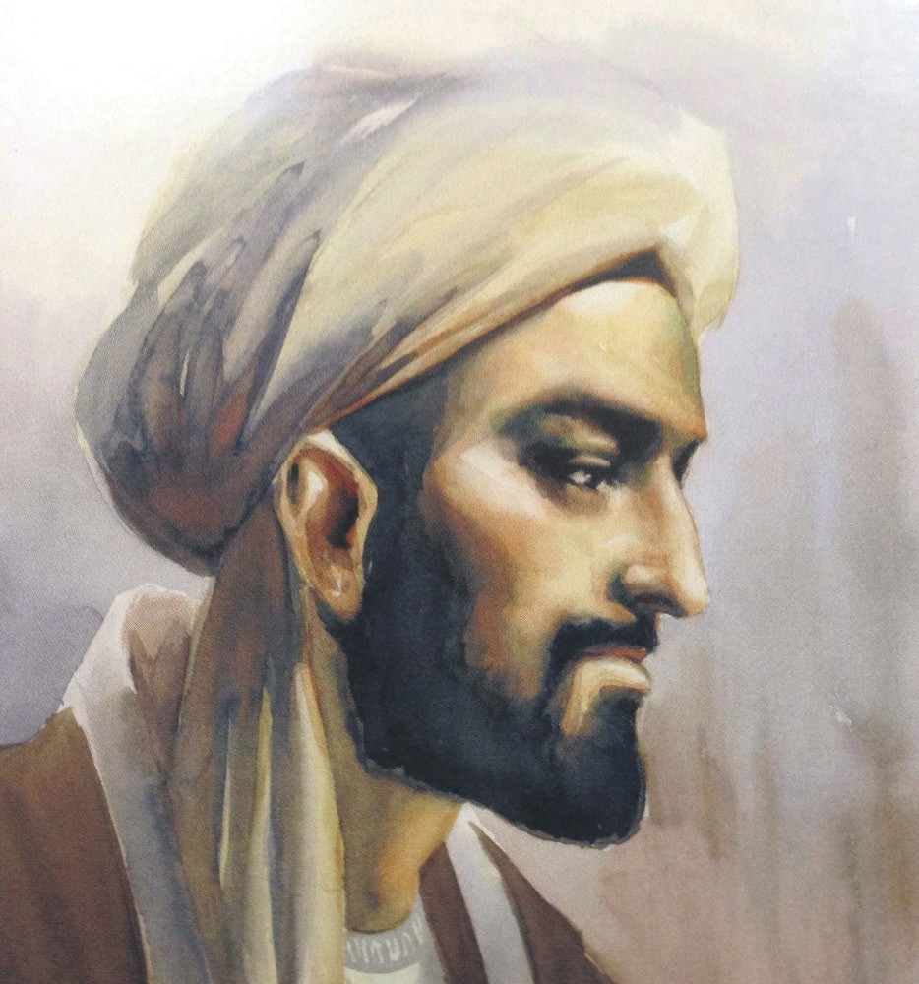

10. Ibn-khaldun

Sources:
- https://tinyurl.com/4s8au2rz
- https://tinyurl.com/bd3f4ds4
- https://tinyurl.com/2psa3hy9
- https://www.thoughtco.com/cicero-4770071
- https://dailystoic.com/seneca-quotes/
- https://islamiceconomics.net/ibn-taymiyyah/
- https://islamiceconomics.net/al-mawardi/
- https://e-history.kz/en/news/show/7125
- https://www.dailysabah.com/portrait/2019/07/19/ibn-sina-top-peripatetic-philosopher
- https://www.dailysabah.com/portrait/2017/03/04/ibn-khaldun-the-14th-century-genius

