Pr Zoubida Sebane L1 Phonetics April 30th
Describing Consonants :
Unlike vowels which need only the tongue to be articulated, consonants require 2 articulators, passive or active.
Consonants are described in terms of their VPM ( Voice / Place of articulation and Manner of articulation). VPM are the consonant features.
A consonant sound may be produced voiced or voiceless , in a particular place of articulation and with a particular manner of articulation.
Fig 1 below shows the places of articulation and vertically the manners of articulation for English consonants
FIG1 The places of articulation
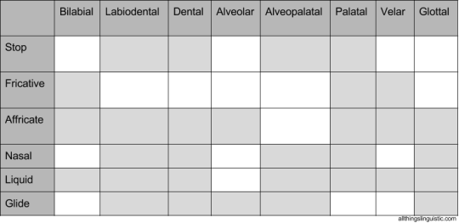

FIG 2 The English consonants
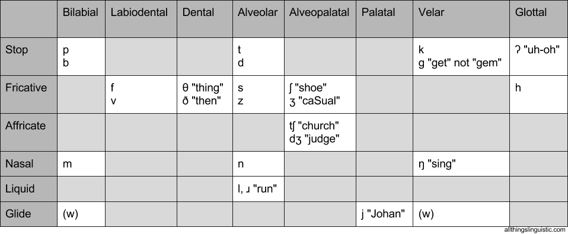
The places of articulation :
- Bilabial : the two lips are involved as for / p, b, m , w /
- Labiodentals : the lower lip and the upper teeth ex : / f , v /
- Dental : the tip of the tongue against the upper teeth : // θ,ð/
- alveolar : the tip of the tongue towards or against the alveolar ridge : /t;d,s ,z, n /
- Alveopalatal : the body of the tongue towards the palate and alveolar ridge:/ ʃ ,ʒ/ // t /tʃ ,dʒ/ /
- Palatal : the body of the tongue towards the hard palate / j /
- Velar : the back of the tongue towards or against the soft palate or the velum : / k,/ /k, g, ŋ/

Glottal : the consonant is produced in the glottal cavity / h, ʔ /

The manners of articulation

Air, stored in the lungs, is used in different manners according to the sound that is produced. For each description ,see fig 2 above.

The stops , also called plosives ,are produced with complete obstruction ( (blockage) of air in the different places of articulation.

There are bilabial, alveolar , velar and glottal stops or plosives.

The fricatives, are produced with a narrow passage of air so that we can hear a friction ( a hissing sound ) in the different places of articulation.

There are labiodentals, dental , alveolar , alveopalatal and glottal.

The affricates are produced by combining a plosive with a fricative .

However , not all plosives with all fricatives can make an affricate , only the pair/ /t ʃ ,dʒ/ is a true afficate.

/tr, dr / is also considered a pair of afficate . / t, d / is a pair of plosives yet, / r / is not an afficate, but when it occurs next to /t, d / it is produced with a friction.

- The nasals sounds are produced in the nasal cavity. ( velum lowered)
There is the bilabial, the alveolar and the velar nasal. They are homorganic with plosives that means they share the same place of articulation as plosives.
- The liquids are oral sounds produced either with the tongue against the alveolar ridge / l / , or the tongue that makes a curve towards the alveolar ridge / r /. Both are alveolar.
- The glides or semi*vowels or approximants are consonants that sound like vowels . / j / in yes is produced with the body of the tongue raising towards the hard palate and / w / in war in articulated with the lips rounded and the back of the tongue towards the velum.
Consonants are made of two classes : the class of obstruents and the class of sonorants

The class of obstruents include mainly the minimal pairs ( voiceless/voiced).
The class of sonorants on the other hand contains only the consonants that occur alone and that are always voiced ( see fig 3 )
FIG 3 represents the two classes of consonants
obstruents | sonorants
Stops or plosives: /p,b/ /t,d/ /k,g/  Fricatives : / f,v/ /θ,ð/ /s,z/ /ʃ ,ʒ/ /h/  Affricates: / tʃ ,dʒ// ,/tr,dr/ | Nasals : /m/ , / n /, / ŋ /  Liquids : / l / , / r /  Glides : / j / , / w /

Sonorant sounds are always produced voiced
Vowels, Nasals , Liquids and Glides are labeled SONORANT sounds.

