The main ideas
What is the most important?

“I am not Athenian, or a Greek. I am a citizen of the world.”

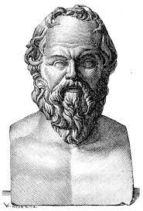

- Socrates

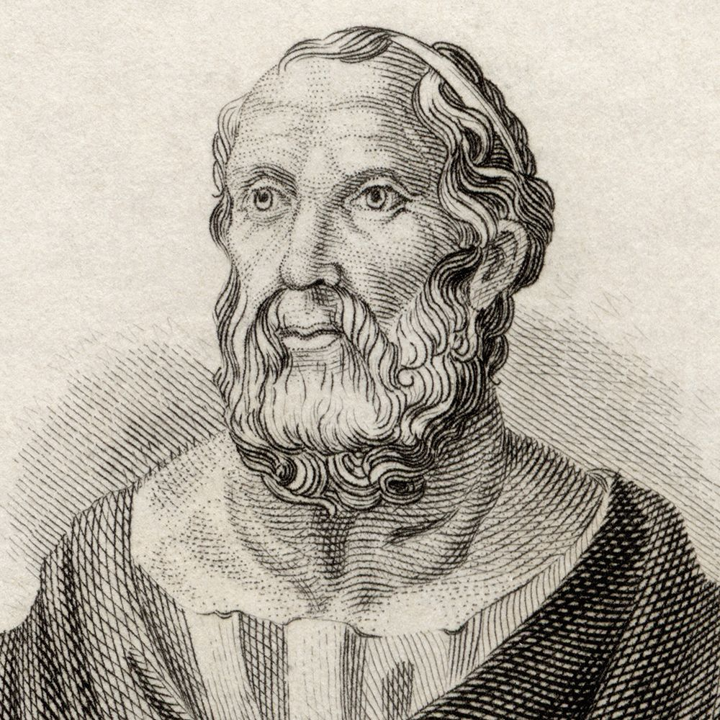

He who does not desire power is fit to hold it.

2. Plato

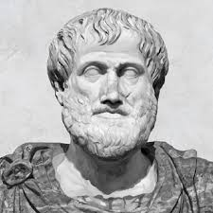

He who is to be a good ruler must have first been ruled.

3. Aristotle

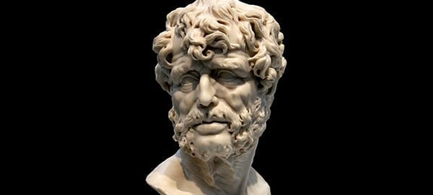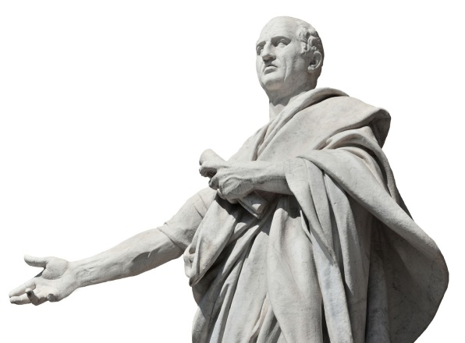
- Cicero

- Seneca

To govern was to serve not to rule.
A hated government does not long survive
Politicians are not born; they are excreted.
A nation can survive its fools, even the ambitious. But it cannot survive treason from within….for the traitor appears not to be a traitor…he rots the soul of a nation…he infects the body politic so that it can no longer resist

Allah guards the justice loving government, even if it is the government of non-Muslims, and destroys the tyrant government, even if it is the government of Muslims
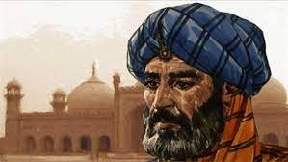

6. Ibn-taymiyyah

There is nothing that leads faster decay of the world and degeneration of people's conscience than injustice
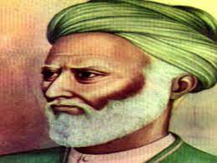

7. Al-mawardi

A just city should favor justice and the just, hate tyranny and injustice, and give them both their just deserts
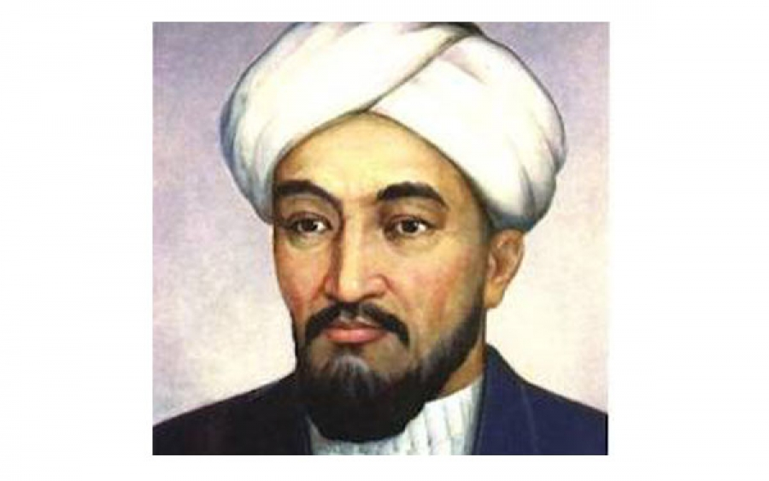

8. AL-farabi

People say that wisdom is precious but the world pays no penny for it
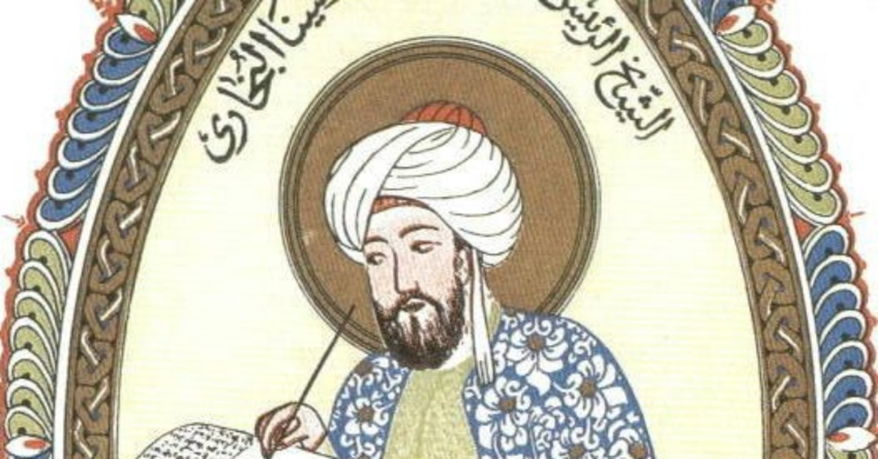

9. Avicenna

Throughout history many nations have suffered a physical defeat, but that has never marked the end of a nation. But when a nation has become the victim of a psychological defeat, then that marks the end of a nation
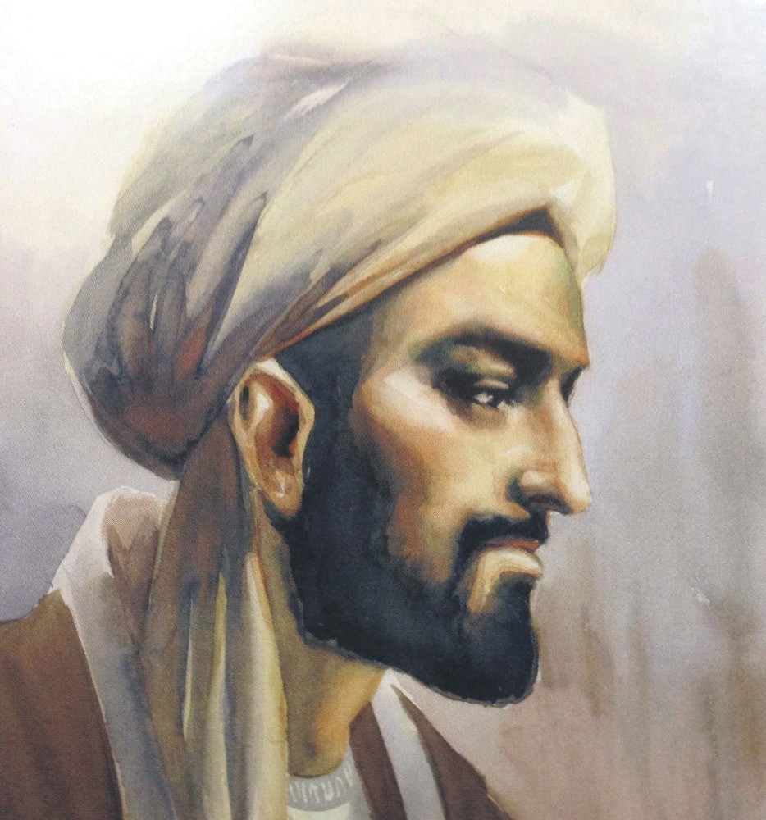

10. Ibn-khaldun

Sources:
- https://tinyurl.com/4s8au2rz
- https://tinyurl.com/bd3f4ds4
- https://tinyurl.com/2psa3hy9
- https://www.thoughtco.com/cicero-4770071
- https://dailystoic.com/seneca-quotes/
- https://islamiceconomics.net/ibn-taymiyyah/
- https://islamiceconomics.net/al-mawardi/
- https://e-history.kz/en/news/show/7125
- https://www.dailysabah.com/portrait/2019/07/19/ibn-sina-top-peripatetic-philosopher
- https://www.dailysabah.com/portrait/2017/03/04/ibn-khaldun-the-14th-century-genius

