L1 Second Term Phonetics Courses addressed to L1 grs C/D/E/F/G/H/I Pr Z Sebane

Diphthong Vowels

IPA Symbol | Word examples
ɪə | Beer, here, dear, fierce, weird, idea
eə | Chair, care, parents, pear, where, their .
eɪ | Radio , rain, day, great, veil, grey
ɔɪ | Joy, employ, , coil, oyster, ointment
aɪ | Blind, pint, sign, write, apply, light, eye, either, buy
əʊ | Ago, home, toe, cold, boat, low, shoulder
aʊ | Now, house, ground, brown,

Note 1: The letter Y
The letter Y can function as a vowel or as a consonant. As a vowel, Y has the vowel sounds [i], [ai]. As a consonant, Y has the consonant sound [y] (i.e., a semivowel sound / j / together with / w /), usually at the beginning of the word and only in the syllable before a vowel.
[i]: any, city, carry, funny, mystery, synonym;
[ai]: my, cry, rely, signify, nylon, type;
[j]: yard, year, yes, yet, yield, you.

Note 2: Diphthongs
A diphthong consists of two simultaneous vowel sounds that occur in the same syllable. The first part is the main strong component (the nucleus); the second part is short and weak (the glide). A diphthong is always stressed on its first component: [au], [ou]. A diphthong forms one syllable. American linguists usually list five diphthongs: [ei], [ai], [au], [oi], [ou].
There are two different diphthongs in English: closing diphthongs and centering diphthongs. Closing diphthongs have a close vowel as second sound (either / i /or / u /. Centering diphthongs , however have a schwa /ə / as the second sound . /uə/,/iə/,/eə/.

Note 3 : A diphthong is a vowel sound . Vowels are free voiced sounds . They belong to the class of sonorants
Note 4: A triphthong is a vowel of English which consists of a sequence of 3 sounds in one syllable.
A triphthong is a made up of a diphthong + the schwa /ə /. All closing diphthongs are possible triphthongs .
Table including the English thriphongs with examples
/ eiə/ | /aiə/ | / ɔiə / | / auə / | /əuə/
Mayor/ layer/ | Fire / buyer /society | Lawyer/ employer | Flower/ sour | Lower /

Description of the English Consonants
A consonant is described in terms of its VPM ( Voice / Place of articulation / Manner of articulation

4-Velum position

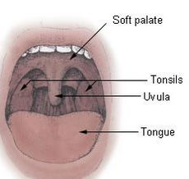

Velum position allows us to distinguish between nasal and oral sounds.

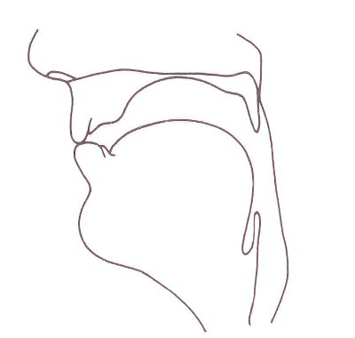

In most speech , the velum (soft palate) is raised so that there is a velic closure and the air is prevented from escaping through the nose. In this way oral sounds are produced and all consonants except for nasals ..
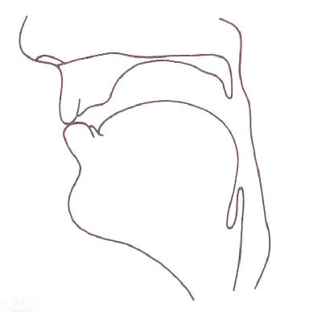

However, velum can also be lowered in which case the air goes through the nose and nasal sounds are formed. In English they include nasal consonants /m/, /n/ and /ŋ /.

5-Place of articulation .

The airstream which goes through the vocal tract must encounter some kind of an obstruction to form a consonantal sound. Consonants are then classified depending on the place and manner of this obstruction known as place and manner of articulation.
Place of articulation refers to the horizontal relationship between the articulators. It specifies the position of the highest point of the active articulator in relation to the passive articulator (the latter gives the name to the place of articulation).
There are three major places of articulation: the lips, the tongue tip & blade and the back of the tongue.
We can distinguish three types of articulations depending on which of the three places is used: labial , coronal and dorsal articulations.

Place of articulation | Articulation type
lips | labial
tongue tip & blade | coronal
the back of the tongue | dorsal
Fig 4 Places of articulation

In order to specify articulatory gestures in sufficient detail, more specific places of articulation have to be distinguished. They are illustrated in the figures below.

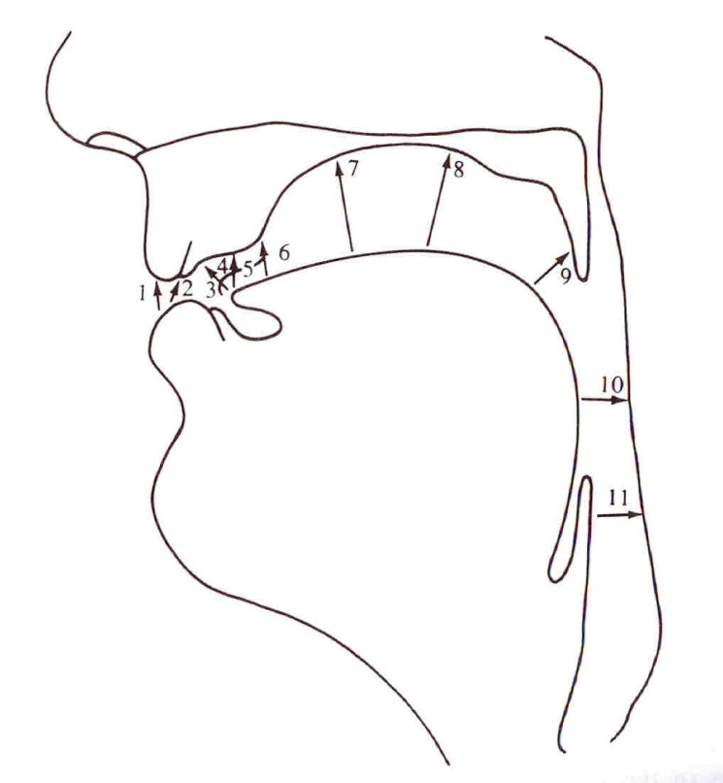
1.bilabial
2. labiodental
3. dental 4. 4Alveolar
5-retroflex
6-palato-alveplar 7. palatal 8. velar
9. uvular
10. pharyngeal
11.larynx

5.1Labial articulations

They include labial and labiodental articulations.

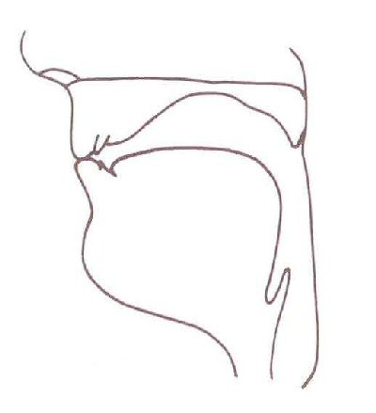
In case of labial consonants the articulation is formed by the upper and lower lip:
/p/ put, /b/ back, /m/ more, /w/ win.

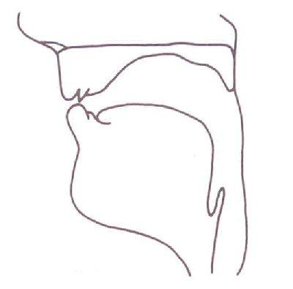
Labialdental consonants are pronounced
using the lower teeth and upper lip: /f /, fan,/ v / van,

5.2 Coronal articulations

They include dental, post-dental, alveolar, post-alveolar, palato-alveolar, alveolo-palatal, palatal and retroflex articulations.

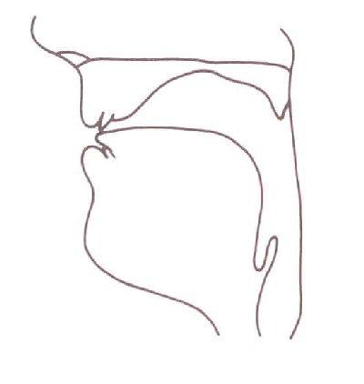
In case of dental consonants , the articulation is formed by the upper teeth and tip of the tongue:
/,θ / thin ,/. ð// that

Post-dental consonants are produced using the tip of the tongue and the upper teeth and the area just behind them: /s/ stay, /z/ zoom

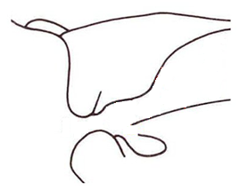
Alveolar consonants : the place of articulation is at the alveolar ridge and tip of the tongue is the active articulator:
/t / time, /d/ day, /l/ late, : /s/ snake , /z/ zebra , /t/ tiger , /d/ dog.

Post-alveolar consonants :the place of articulation is at the front of the hard palate and blade of the tongue is the active articulator: /r/, rare

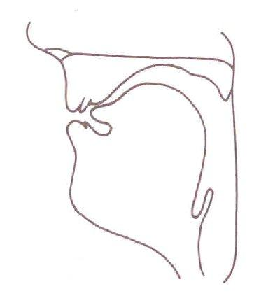

Palato-alveolar consonants :the place of articulation is at the back of the alveolar ridge and blade of the tongue is the active articulator:
English /ʃ/ shame , /ʒ/ measure

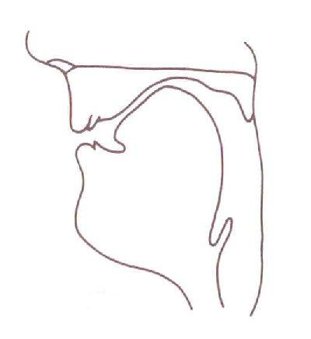
Palatal consonants : the place of articulation is at the hard palate and the front of the tongue is the active articulator:
/j/ yet

Retroflex consonants : the place of articulation is at the back of the alveolar ridge and the tip of the tongue is the active articulator. English (only optionally): / tr / try , / dr/ dry.

5.3 Dorsal articulations

They include velar, uvular, pharyngeal and glottal articulations.
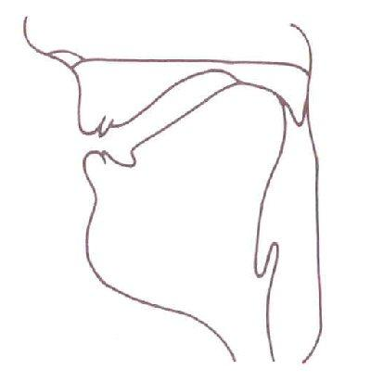
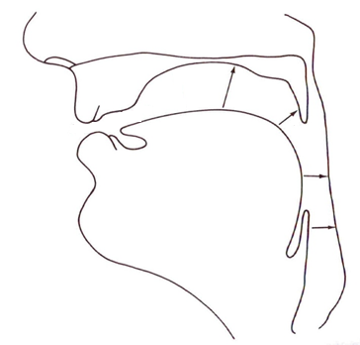
Velar consonants :the place of articulation is at velum (soft palate) and back of the tongue is the active articulator:
/k/ cry , /g/ get , /ŋ/ sing

Uvular consonants are formed by the back of the tongue and uvula, e.g.
velar
French“rat”
r
Pharyngeal consonants are formed by tongue root and pharynx wall. Arabic / (/ħ//aħmar ,red and /ʕ/ ʕein/ eye
eal

l
Glottal consonants : The vocal cords are the active and passive articulator:
/ʔ / /noʔnau/, not now ( when /t/ is followed by a consonant.

Articulators Places of articulation
…………………………………………………………………………

Lips ……………………………… | Labial
Lips and upper teeth……………………………… | Labiodental
Teeth ……………………………… | Dental
Onset of the palate ……………………………… | Alveolar
Further onset of the palate……………………. | Post alveolar
Mid part of the palate…………………………… | palatal
Between onset and mid part…………………. | Alveo-palatal /Palato-alveolar
Soft palate / Velum …………………………… | Velar
Uvula …………………………… | Uvular
Pharynx …………………………… | Pharyngeal
Glottis ………………………….. | Glottal
…………………………………………………………………………
Fig 5 articulators and their corresponding places of articulation

6.Manner of articulation

6.1 Stops

Stops are produced with a complete closure of the speech organs involved in their articulation so that the airstream can not escape through the mouth. If the soft palate is raised and the nasal tract is blocked off then an oral stop will be produced. The pressure will built up in the oral cavity and when the articulators come apart the pressure will be released and a small burst will be heard.
In English there are three classes of oral stops: labial /p/, /b/, dental /t/, /d/ and velar /k/, /g/, and the glottal stop / ʔ /
If the soft palate is lowered and the nasal tract is opened then a nasal stop will be produced.
It should be noted that the term stops is usually used in the meaning „oral stops”, whereas nasal stops are referred to as nasals .
Nasal stops in Enlish include bilabial /m/, dental /n/ and velar /ŋ/.

6.2 Fricatives

Fricatives are speech sounds produced with a close approximation of two articulators which form an obstruction and create a turbulent airflow.
English fricatives include labiodental /f/, /v/, dental / /,θ / / ð/, alveolar/s/, /z/,
/ palato-alveolar /ʃ/, /ʒ/,

-6.3 Affricates

Production of affricates involves more than one manner of articulation - they are formed as a combination of a stop followed by a fricative of the same place of articulation: post-dental /tr/, /dr/, alveo-palatal /tʃ/, /dʒ/

6.4 Liquids

In the production of liquids the articulators approach each other, but to such an extent that there is a free passage of air through the oral tract, e.g. lateral /l/
the centre of the tongue is in contact with the alveolar ridge but the air flows freely over the lowered sides of the tongue.
trill /r/ – the sides of the tongue are in contact with the gums, but the air flows freely down the centre of the tongue.

6.5 Glides, semi-vowels or approximants

The articulation of glides differs from that of consonants and vowels.
There are two criteria for the distinction of glides: the first one is refers to their articulation and the other one refers to phonology, i.e. how they function in the language.
Comparing to consonants, in the production of glides the active and passive articulators create a wide stricture and the airstream flows through it unhindered, which is similar to the articulation of vowels.
However, what differs glides from vowels from the perspective of the articulation is the unstable position of the articulators:
/j/ and /w/ are produced with the same position of the articulators as /i/ and /I/ respectively, but the stricture formed by the articulators is narrower in case of the glides than the corresponding vowels.
The unstable position of the articulators means that if we try to „prolong” the articulation of the sound /j/ or /w/ after a while it will turn into its corresponding vowel as a result of the stabilization of the articulators.
Like consonants, glides do not comprise the nucleus of the syllable.
Glides and liquids are classified as approximants .Together with nasals , liquids and vowels they belong to sonorants .

Pr Z Sebane

Easy Emergency Phonetics Guide

A Practical Manual of Phonetics for Beginners

Edited in Dar elgharb

